**University Of Engineering And Technology**



**College Management Project in Python**

**Group Members:**

1. Mehmood Ul Haq 2021-CE-35
2. Muhammad Shahzaib 2021-CE-41
3. Kashif Muneer 2021-CE-34

**Submitted To*:***

Raja Muzammal Muneer

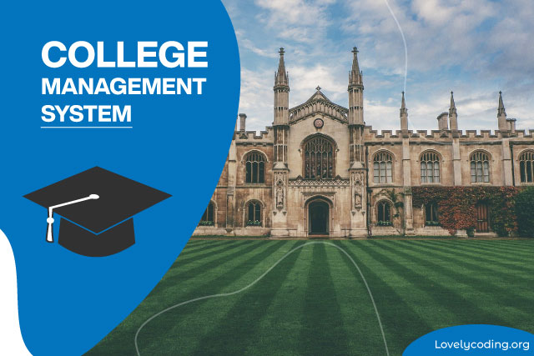

## **Abstract:**

This College Management System aim to solve problems related to college. These are the set of outputs that can be gain by using this program:

* Managing Students Fee
* Manage Syllabus
* Attendance Management
* Subjects Update

## **Objective:**

1. This project will provide us with the critical knowledge of python programing.
2. This is a fully functional GUI base project developed in python that covers all of the features that an IT student needs to make a college management system.
3. We will become familiar to interact with Graphical interface within python
4. It will provide practical experience and understanding by working on different projects.

## **Socio and Economic Benefits:**

1. It provides information to the organization to management activities efficiently.
2. Students can easily know about their subjects they currently studying.
3. Student can easily apply for college for admission.
4. Teacher can mark the attendance of the student.
5. Principal can easily update the syllabus.

## **Tools and Software:**

Visual Studio Code (VS Code)

**References:**

* Code with Harry (You Tube)
* Parvat Computer Technology (You Tube)
* Towards Data Science (Website)